
MAMC01814: User Experience Design: Design Report
ASSESSMENT 2
Study block | Block 4 2025
Due date | Monday 22nd September |  | Time | Before 11.59 PM
Delivery: | Submit to Turnitin via Moodle before deadline
Weighting | 70%
Marks out of | 100
Instructions | Complete this cover sheet and attach to you your assignment.  - This assignment must be your own work.  - Collusion, copying or plagiarism may result in disciplinary action.  - We advise that you keep a copy of this assignment.  Refer to following website for reference related resources:  http://www.cite.auckland.ac.nz/index.php?p=quickcite
Student Name | Gielo Joseph Fernandez
Student ID No | 737214696 | Cohort number |  |  |  | 1
Lecturer | Shafiq Alam | Class time |  |  |  | Mon & Wed 8:30am-12:30pm
Student declaration: | I confirm that:  This is an original assessment and is entirely my own work.  Where ideas, tables, diagrams etc. of other writers have been used, I have acknowledged the source in every case.  This assignment has not been, nor will be, submitted as assessed work for any other academic course.
Signature of student: | Gielo Joseph Fernandez |  |  |  | Date |  | August 20, 2025
A Critical Analysis of User Experience Design on AA Travel Insurance Quote Function
1. Introduction
(300 words)
In today’s age, User Experience plays a huge part in the success of organizations. User Experience, although it was first coined by cognitive scientist Don Norman in the 1990s, User Experience goes way back much farther than the 1990s (Young, 2022). User Experience (UX), often shortened for UX, is defined as the overall experience a customer or user has when interacting with a product, system, or service. UX handles all the user’s feelings about the product, including ease of use, accessibility, visual design, functions, and emotional impact (Finn & Downie, 2025). For users, UX is the whole interaction that they experienced with a product or service.
AA Insurance, a New Zealand company founded in 1994. AA Insurance has been offering insurance to New Zealanders for 30 years (Our Company and Our People - Find out More | AA Insurance, n.d.)
This report will analyse how user experience design can improve the functionality of travel insurance in AA Insurance company. Part two will discuss in detail the user experience elements, usability, accessibility, and aesthetics as they are important in achieving the goals of AA Insurance in the insurance industry. Part three will discuss the best practices of current organizations in how they implement these user experience elements. Part four will discuss Alternate design to further improve the user experience design of AA Insurance. Part 5 will end with summary and conclusion.
2. Analysis of the Current AA Travel Insurance
(600 words)
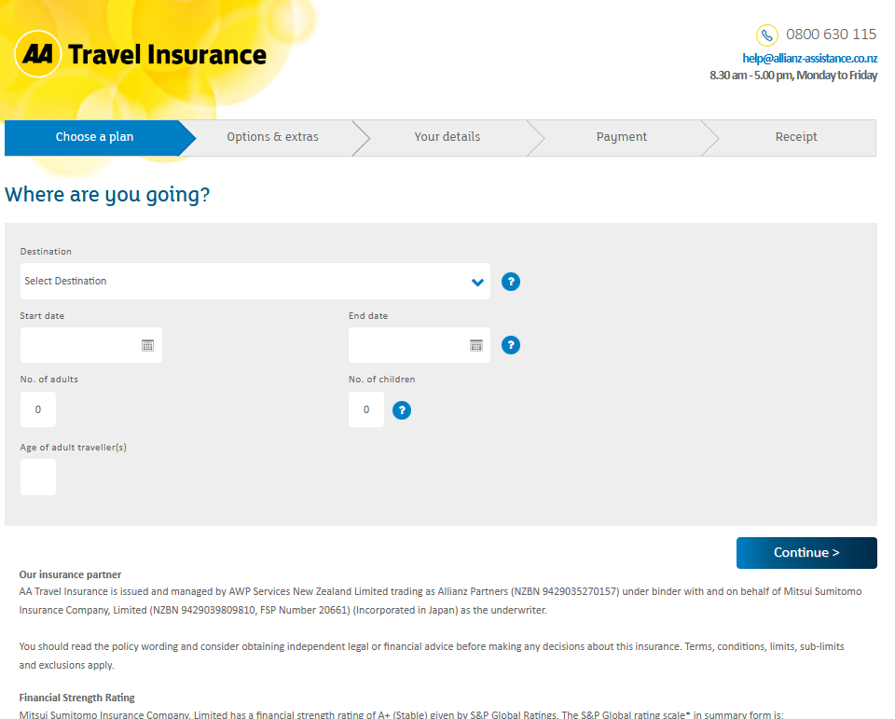
Figure 1 AA Travel Insurance Quote Page
The AA Travel Insurance Quote Page (AA Travel Insurance, n.d.) provides services such as domestic, and overseas travel insurance. It asks for the destination, start date, end date, number of adults, number of children, and the ages of the travellers. In case the user needs help, the page contains the email, contact number and the availability of the travel insurance agent.

Figure 2 AA Travel Insurance Logo
The quote page contains the logo of AA and the label Travel insurance. This is to help the users know that they are accessing the travel insurance and not to be confused with other insurances offered by AA.
Figure 3 Travel Insurance Steps
The quote page contains the phases/steps, which guides the users throughout the travel insurance purchase cycle. This helps users know what phases/steps and be guided accordingly.

Figure 4 Insurance agent contact info
The quote page contains the contact number, email address, and the availability of the insurance agent. This is to inform the user if they have any questions or need assistance.
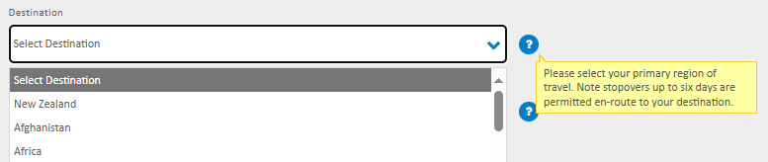
Figure 5 Select Destination
The quote page contains the select destination field, which asks the user to select the destination of their travel. In the scenario that the user is going to multiple countries, there is the tooltip that is displayed when hovered which informs the user about it.
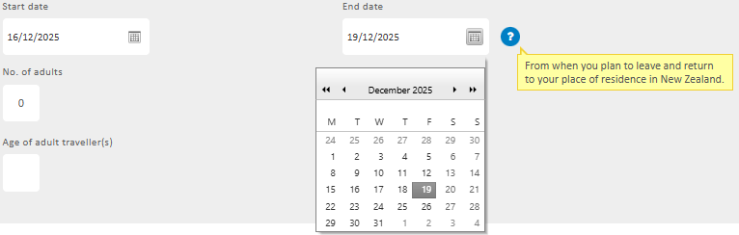
Figure 6 Select Start and End Date
The quote page contains the field where select start and end date, which asks the user to select when the start and end of their travel. It is in calendar format to help to easily identify the dates. There is added tooltip to inform the user more information about the dates.
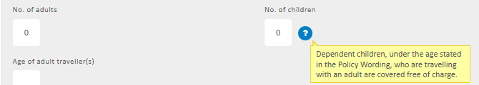
Figure 7 Enter No. of adults and children
The quote page contains the fields to enter the number of adults and children. This is to indicate how many adults and children will be covered in this travel insurance policy. There is added tooltip to inform the user more information about the children.
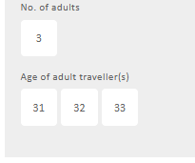
Figure 8 Age of adult traveller(s) Field
The quote page contains the field to enter the ages of the adult travellers that will be covered in this policy. The number of fields depends on the number of adults (ex. 3 adults – 3 fields).

Figure 9 AA Travel Insurance Continue Button
The quote page contains the ‘Continue’ button. After the user enters the destination, start date, end date, number of adults & children, and the age of adults. The continue button proceeds to the next step which is the selection of plan.
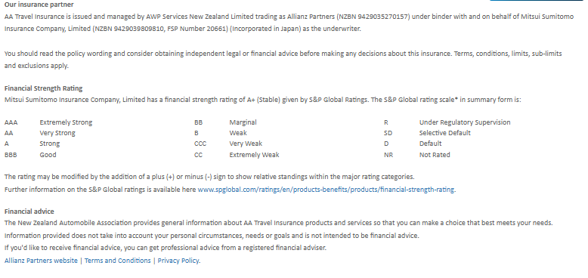
Figure 10 AA Travel Insurance Footer
The quote page contains the footer, which contains the insurance partner details, financial strength rating, financial advice disclaimer, and other information(partner websites, terms and conditions, privacy policies).
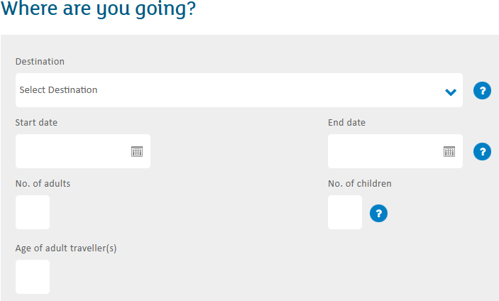
Figure 11 Entering User Info
In terms of usability, the AA Travel Insurance quote page uses simple labels such as ‘Destination’, ‘Start date’, ‘End date’, ‘No. of adults’, ‘No. of children’, ‘Age of adult travellers’. This is to make sure users are familiar with it even for first time users, as these users spend most of their time on other sites, users expect AA Travel Insurance to function like all the other sites they already know (Nielsen, 2023).
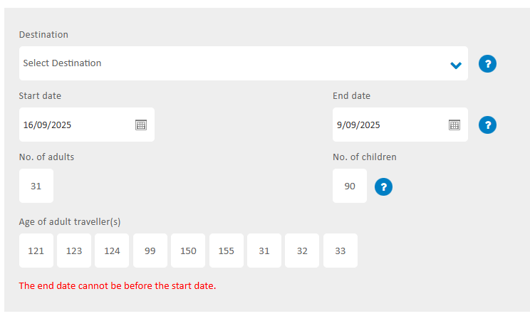
Figure 12 Error Checking
However, in terms of error checking,
In terms of usability, the AA travel insurance Quote Page uses a straightforward form-based interface that guides users through essential inputs efficiently, aligning with best practices that emphasize simplicity and clarity. The form fields are well-labelled and encourage quick completion, aligning with Jakob Nielsen’s usability heuristics such as "recognition rather than recall" and "aesthetic and minimalist design"
https://en.wikipedia.org/wiki/Web_usability
In terms of aesthetics, the AA website maintains a clean, professional look with consistent color usage and clear typography, reflecting strong brand cohesion and readability. The use of images and a simple layout contributes to trustworthiness and ease of orientation—key aesthetic components in insurance web design
Importantly, the website benefits from the aesthetic–usability effect, meaning users are likely to perceive it as more intuitive simply because it looks polished—even if certain functional improvements are needed
https://www.webstacks.com/blog/insurance-website-design
In terms of the AA travel insurance website in general, the form in the website is well-structured and easy to follow, enabling users to get quotes efficiently. The site employs a unified color palette (yellow, white and black), consistent typography, and high-quality images—hallmarks of visually cohesive and professional UX design. The trust and credibility of AA is also good as the AA brand is well-established and viewed as reputable in New Zealand, and the site reinforces this trust through clear messaging and visible support channels. The site uses cookies to save previously entered data, which is helpful for users when they access the website again.
https://www.insurancebusinessmag.com/nz/news/breaking-news/aa-insurance-one-of-nzs-most-reputable-brands--survey-164781.aspx
However, the AA travel insurance website lacks live chat or chat bot functionality to guide users interactively—particularly useful for complex decisions like travel insurance where FAQs or in-the-moment assistance can reduce friction. Many modern insurers embed chatbots to streamline support and improve conversion. The website doesn’t offer customized options for multi-trip/destination and student-specific policies—missed opportunities for personalization that could improve relevance and increase sales.
Lorem ipsum Dolor Sit Amet
First Paragraph - Background of the function/ Goals (one small paragraph)
The current chatbot provides services such as ....

Second Paragraph - Focusing on the core component/s (usability, aesthetics, accessibility, personalisation or whatever)

In terms of usability, the mobile apps, chatbot UX is ..... (telling me how the current app is in terms of your selected component)

3rd Paragraph: What are the good things, and what are the negatives ( remember to focus on the negatives more... because this will provide basis for your next sections) (remember its explanatory/or descriptive/ its not comparative)

• Analyse the user experience design of the chosen organisation, which may include but not limited to usability, accessibility, and aesthetics. Use examples from your organisation’s user interface (Mobile App, website, or any other system)
Analysis - include screenshot of the existing user interface

screenshots are important

functions you are analyzing
and how people use it

login function in terms of user experience

insurance quote function in terms of user experience
3. Evaluation of User Experience Design of AA Insurance Travel Insurance Page
(900 words)
Lorem ipsum Dolor Sit Amet\
First paragraph - This part is comparative which means( compare the current UX in terms of the component you choose such as usability against usability principles(research on it))

Second Paragraph - What are the areas of improvement for example whatever is missing or not good in terms of best practices (current trends)

3rd Paragraph - What are the areas of improvement for example whatever is missing or not good in terms of best practices (future developments)

(to write these section keep in mind to focus on the ux not the organization)

• Based on your analysis in step 1, evaluate how the organisation's user experience design aligns with best practices in user-centred interaction design. Identify any areas where the organisation's user experience design falls short and needs improvement according to user-centred design principles.
Evaluation - In the evaluation,
ANZ has a mobile app that provides a chat function - description / not evaluation

ANZ has a chat function which does not properly work - analyzing

ANZ has a mobile app that is very limited - analyzing

is compared to in terms of
1. has these issues in compared to usability principles/user experience/best principles

2. and compared to these/other organization
compare to other good organization

3. compare function to function(other industry)

compare side by side and compare it

Air NZ has one of the best designs that it is following
certain principles, but it is not following this principle

Addressing cultural biases
improve user experience by including of local tradition and norms and that it well used

avoiding any bias or stereotypes

ANZ should be aking care on

motibvations - eternal api
what is explainability

transparency and fairness

explainability is the key to the foundation of AI
4. Design of the recommended AA Insurance Travel Insurance Page
(900 words)
(feel free to put images from the existing apps and comparative apps, etc and point to them)
Lorem ipsum Dolor Sit Amet
Design
-Make the design
-Connect evaluation
-AS a design fix in the issue it is in the design section

these are the good things
these are the bad things

-How important is AI in contemporary

discuss positive and negative effects of AI
If it is using AI, what should the organization be careful about

The problems I have identified , can be solved with AI solutions, however. AI has issues with ...

Then discuess the designs created
5. Conclusion
(300 words)
Lorem ipsum Dolor Sit Amet
6. References
AA Travel Insurance. (n.d.). Retrieved September 8, 2025, from https://travelinsurance.aa.co.nz/processing/ChooseAPlan.aspx
Finn, T., & Downie, A. (2025, January 10). What is user experience (UX)? https://www.ibm.com/think/topics/user-experience
Nielsen, J. (2023, September 8). Jakob’s Law of the Internet User Experience. UX Tigers. https://www.uxtigers.com/post/jakobs-law
Our company and our people—Find out more | AA Insurance. (n.d.). Retrieved August 21, 2025, from https://www.aainsurance.co.nz/about-us/about-our-company
Young, N. (2022, March 30). The Past, Present and Future of User Experience (UX) Design. https://extendedstudies.ucsd.edu/news-events/extended-studies-blog/the-past-present-and-future-of-user-experience-(ux)-design

